24th Mar 2025

Testing potting of electrospun hollow fibers

Overview:
- eHFs need to be potted into the bioreactor chamber
- Fiber potting will be tested in pre-cut 3mL syringes

Procedure:
- Cut the ends of a 3mL syringe
- Prepare three fibers without core
- Place the fibers inside the syringe
- Add polyurethan resin (P.U. Glue)
- Let the resin cure for min. 12 hours
- Cut the fibers and check for an open fiber lumen

Notes:
- If the resin is too viscous, it will not reach between the fibers
- If the resin is not viscous enough, the capillary effect will cause it to flow into the fibers

Results:
- Potting of fibers without core worked well

- Ease/Practicality of potting (important for scale-up): Easy for three fibers. Might become more challenging large amounts of fibers. May require a removable lid to assist fiber potting
- Material compatibility with PCL: No effects on PCL were noted
- Fiber contamination (Material traveling beyond the potting area): No material noted inside fibers. Need to cut closer to the potting area for further analysis
- Ease of cutting: Fibers were cut outside the resin area. Need to identify feasibility of this when large numbers of fibers are potted
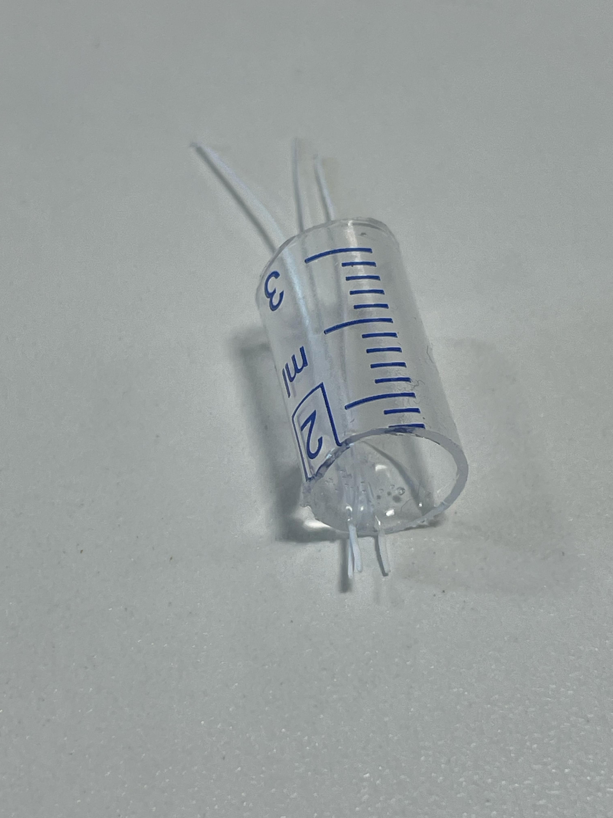
Next steps:
- A different resin will be tested
- Potting with larger numbers of fibers needs to be tested
- Leakage needs to be analyzed
- Biocompatibility needs to be tested

